Julianne Moore to Interview Amy Cuddy
About Her Forthcoming Book PRESENCE
At Book Expo America
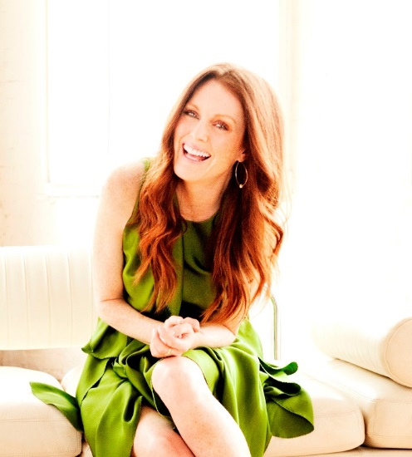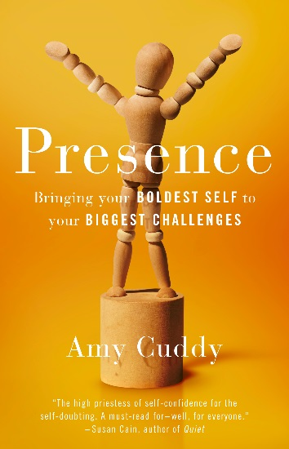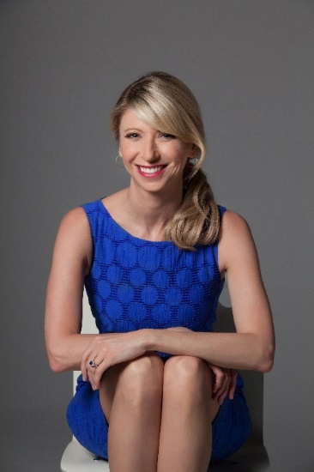
JM Photo Credit: Brian Bowen-Smith/AC Photo Credit: Kelly Campbell
“Amy Cuddy is the high priestess of self-confidence for the self-doubting. In PRESENCE, she uses her warmth, empathy, and laser-sharp intelligence to decode the mysteries of presence under social pressure. A must-read for — well, for everyone.”
—Susan Cain, co-founder of Quiet Revolution and author of the New York Times bestseller Quiet: The Power of Introverts in a World That Can’t Stop Talking

Monday, May 11, NEW YORK, NY – It was announced today that Harvard Psychologist and TED Star Amy Cuddy will appear at Book Expo America on-stage and in-conversation with Academy Award Winning actress Julianne Moore on Thursday, May 28th at 3:00-3:50pm in Room 1E10 at the Jacob K. Javits Center in New York City.
Amy Cuddy says, "Julianne Moore is an intuitive expert on presence. ​There is no practitioner of presence who understands and explains its mechanics and intricacies better than Julianne. And she manages to practice it in all parts of her life."
The event, titled PRESENCE: Bringing Your Boldest Self to Your Biggest Challenges, is based on Cuddy’s forthcoming book of the same name, to be published by Little, Brown and Company on November 3, 2015. Amy Cuddy galvanized viewers around the world with her TED talk about "power poses." Now she explains the science underlying these and many other fascinating body-mind effects, and teaches us how to use this science to become self-assured in high-pressure moments.
Harvard professor Amy Cuddy shows us we need to stop worrying about the impression we're making on others, and instead change the impression we're making on ourselves. Cutting-edge science reveals that if we adopt behaviors reflecting power and strength, we liberate ourselves from the fears and doubts that obstruct us. By redirecting our thoughts, actions, and even physiology, we free ourselves to be our best.
Amy Cuddy is a professor and researcher at Harvard Business School who studies how nonverbal behavior and snap judgments affect people. Her research has been published in top academic journals and covered by CNN, New York Times, Economist, Wired, Fast Company, and Wall Street Journal. In 2013, Business Insider named Cuddy one of "50 Women Who Are Changing the World." In 2014, the World Economic Forum named her a Young Global Leader. Her 2012 TED Talk has been viewed over 25 million times.
Julianne Moore is an actor who is internationally admired for her luminous portrayals of complex and explosive characters on screen. Her presence has been felt in such iconic films as Boogie Nights, The Hours, Far from Heaven, and The End of the Affair, and recently, in Still Alice, for which she received the Academy Award for Best Actress. Julianne Moore is also the New York Times-bestselling author of six books for children, with two new titles releasing this summer. When she is not making movies, she lives in New York City with her family.
"With advice that is both practical and profound, Amy Cuddy shows how to summon your true and best self when doing so matters most. Emotions are contagious. If you personify poise and optimism yourself, you enhance the odds that they will respond in kind."
--Michael Wheeler, Harvard Business School, author of The Art of Negotiation
Little, Brown and Company is a division of Hachette Book Group. Founded in 1837, Little, Brown has long been recognized as a publisher committed to publishing fiction of the highest quality and nonfiction of lasting significance. Hachette Book Group is a leading trade publisher based in New York and a division of Hachette Livre, the third largest trade and educational publisher in the world.
# # #

For further information please contact Nicole Dewey at 212-364-1204 or email: Nicole.Dewey@hbgusa.com

