CBS LAUNCHES “CBS SMALL BUSINESS PULSE,” A NEW DIGITAL BRAND AIMED AT
HELPING SMALL BUSINESS OWNERS SUCCEED

Features Original Editorial and Curated Content Relevant to
Small Business Owners from Across Divisions of CBS Corporation

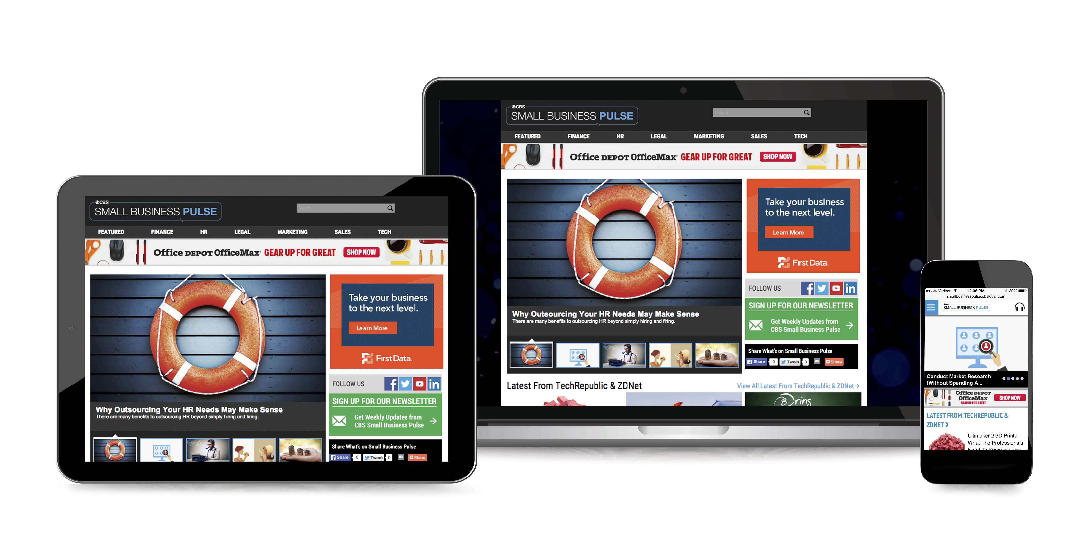
July 1, 2015 – Today, CBS announced the launch of CBS Small Business Pulse, a new digital property aimed at providing solutions for the issues and concerns small business owners face every day. The site, http://cbspulse.com, is a cross-divisional effort across CBS Corporation being spearheaded by CBS Local Digital Media and features content from across the Company’s world-class editorial organizations including CBS News, CBS Radio, CBS Local, CBS Interactive and Simon & Schuster.

“CBS Small Business Pulse brings together the best content from across many CBS divisions plus new, original editorial on the topics that matter most to small business owners,” said Ezra Kucharz, President of CBS Local Digital Media. “CBS Small Business Pulse will provide the insights and knowledge small business owners need to immediately solve the challenges they face by delivering daily, easily digestible information across myriad topics that can easily be put into action.”

CBS Small Business Pulse is structured around six major categories that small business owners must address on a daily basis regardless of their industry: Finance, Human Resources, Legal, Marketing, Sales and Technology.

Content in CBS Small Business Pulse will be fueled by many CBS divisions and include subject-matter experts and business leaders sharing their acumen through articles, interviews, video, podcasts and infographics. Examples include:

- CBS News: In addition to curated content relevant for small business owners, CBS News will also be contributing original content. Following interviews on CBS News’ broadcasts, such as CBS THIS MORNING, producers will record additional segments with business leaders discussing small business-focused issues exclusively for CBS Small Business Pulse.
- CBS Local: Daily original and curated content highlighting small business successes and key learnings from across the country.
- CBS Radio: Video highlights from Small Business Breakfasts held by News format stations around the country.
- ZDNet and TechRepublic (CBS Interactive): Stories about small business strategies as it relates to technology, products and services.
- Simon & Schuster: Contributions include excerpts and original content from Simon & Schuster authors as well as a small business “book shelf” highlighting special offers on relevant titles from their library.

“Small business owners are the backbone of America,” said Rich Lobel, Executive Vice President and CMO, CBS Altitude Group. “So many divisions across CBS offer content and expertise related to small business owner’s needs, it only made sense to harness our world-class editorial organizations to super-serve this vital segment in one single, robust destination.”

CBS Small Business Pulse is advertising supported and offers partners native advertising opportunities where they can share their voice and expertise through sponsored content within relevant content verticals. Founding partners include First Data Corporation, which provides small businesses with the innovative technology solutions they need to reach their fullest potential; Bank of America Merchant Services, a leading electronic payments company providing a host of retail and ecommerce platforms alongside the latest innovative technology; and Office Depot, Inc., a leading global provider of office products, services, and solutions and parent company of Office Depot and OfficeMax.

"First Data is thrilled to be partnering with CBS on the launch of CBS Small Business Pulse, which will provide a one-stop shop for small businesses looking for resources and information to fuel their success," said Gretchen Garrigues, Chief Marketing Officer for First Data. "At First Data, we are committed to providing small businesses with product and technology solutions to help their businesses grow. Partnering with CBS on this initiative is a great way for us to deliver tailored content to small business owners and provide access to information customized to meet their specific needs, without all the noise."

“We believe that CBS Small Business Pulse will be a valuable resource for insights on how to better run and grow small businesses. We look forward to sharing our thought leadership content on a variety of finance and finance related topics – including digital and mobile payments innovation, cybersecurity, fraud and EMV - the new standards for chip payment cards,” says Michael Roberts, Chief Marketing and Digital Strategy Officer of Bank of America Merchant Services. “For example, our research shows that small business owners feel their risk is low regarding credit card fraud and data breaches, where the actual risk may be much higher. Providing real world insights as an advocate for small business owners is our goal with CBS Small Business Pulse.”

CBS Small Business Pulse is available today online and on the mobile web at http://cbspulse.com.

About CBS Local Digital Media
Combining the assets of CBS’s owned television and radio stations, CBS Local Digital Media brings together the most trusted brands in media offering visitors a truly “local” experience. Two dozen major market-specific portals, music and lifestyle websites, apps and local commerce platforms take an active role in reaching more than 65 million unique monthly consumers with extensive coverage of news, traffic, weather, sports and entertainment, as well as CBS Local Offers, Best of Guides and business directories. Live audio and video streams and a library of on-demand content from all CBS local stations are available allowing consumers to experience award-winning original programming whether at home, the office or on the go.

* * *

Press Contacts:
Morgan Seal 646-424-4321 morgan.seal@cbsi.com

