Winners of the 2015 Bancroft Prize Announced

NEW YORK, March 26, 2015 - Columbia University announced today that two acclaimed works will be awarded the 2015 Bancroft Prize:
Empire of Cotton: A Global History by Sven Beckert (Alfred A. Knopf, 2014) and The Empire of Necessity by Greg Grandin (Metropolitan Books/Henry Holt & Company, 2014).

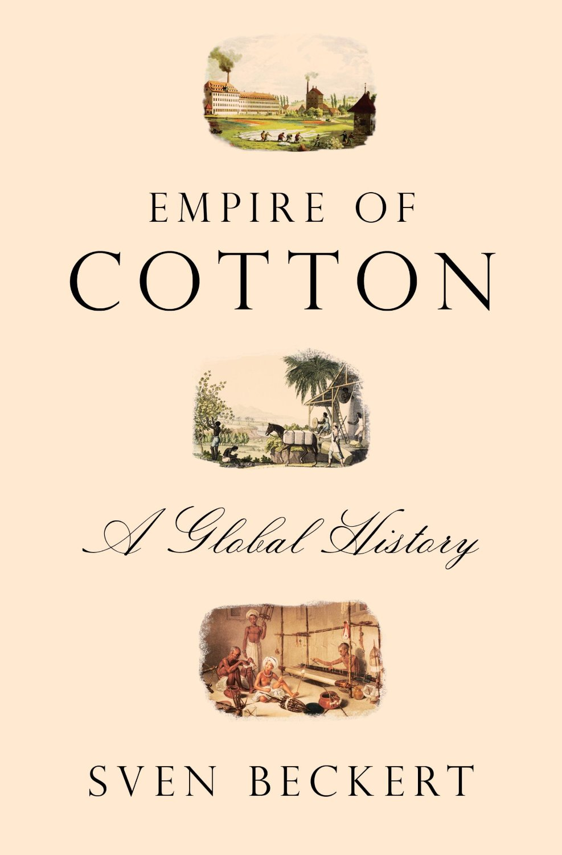
Empire of Cotton is a masterful achievement in the burgeoning field of the study of capitalism. Told through the story of a single commodity, it is nothing less than a history of the globalization of capitalism in the 19th century. Beckert shows that process to have been brutal and violent, not only in the American slave South, but, after the Civil War, in the destruction of local economies and subsistence agriculture in Asia and the Middle East, which pushed peasants to commercial production. Empire of Cotton is an expansive global history that also helps us rethink the history of the United States, lifting our understanding of American slavery, cotton production, the Civil War, and Reconstruction out of the parochial confines of nation-centered history. Deeply researched across four continents and cogently argued, it is a book that will have lasting value for students of the United States and the 19th-century world.
The Empire of Necessity revisits an extraordinary, dramatic high-seas encounter in the South Pacific in 1805 to de-center the history of African slavery in the Americas. With prodigious research, Grandin reconstructs the complex processes and tortuous journeys that brought New Englander Amasa Delano and his crew of seal hunters into fateful contact with a Spanish ship under the invisible control of the enslaved men and women it was supposed to be transporting. Grandin’s eloquent retelling of the story, like Herman Melville’s novella Benito Cereno before it, animates a thoughtful meditation on the meanings of slavery; it is also a gripping and deeply erudite demonstration of the global reaches and ramifications of the slave trade during the age of revolution.
The Bancroft Prize is awarded annually by the trustees of Columbia University. Winners are judged in terms of the scope, significance, depth of research, and richness of interpretation they present in the areas of American history and diplomacy. There were 135 books nominated that were considered for the 2015 prize.
Columbia Provost John H. Coatsworth will present the awards at the Bancroft Prize dinner next month, hosted by the department of history and Columbia University Libraries. The Bancroft Prize, which includes an award of $10,000 to each author, is administered by interim vice provost and University Librarian, Damon E. Jaggars.
“We are excited to award the Bancroft Prize to two extraordinary works, both deeply researched and offering important new interpretations of their historical subjects. We congratulate Sven Beckert and Greg Grandin for their exceptional achievements,” Jaggars said.
Sven Beckert, Laird Bell Professor of History at Harvard University, is co-chair of the Program on the Study of Capitalism at Harvard and co-chair of the Weatherhead Initiative on Global History. Professor Beckert researches and teaches the history of the United States in the 19th century, with a particular emphasis on the history of capitalism, including its economic, social, political, and transnational dimensions. The recipient of fellowships from the Guggenheim Foundation, the American Council of Learned Societies, and the Cullman Center at the New York Public Library, among others, Beckert has published The Monied Metropolis: New York City and the Consolidation of the American Bourgeoisie (Cambridge University Press, 2001) and numerous articles, and edited collections on American and global history. Together with a group of students, he has also worked on the historical connections between Harvard and slavery and published Harvard and Slavery: Seeking a Forgotten History.
Greg Grandin is a professor of history at New York University and a member of the American Academy of Arts and Sciences. His previous book, Fordlandia: The Rise and Fall of Henry Ford’s Lost Jungle City, was a finalist for the Pulitzer Prize, the National Book Award, and the National Book Critics Circle Award. He has published in The New York Times, Harper’s, The London Review of Books, The Boston Review, The Los Angeles Times, and The American Historical Review, and writes regularly for The Nation. He has been a frequent guest on Democracy Now! and has appeared regularly on TV and radio, including on The Charlie Rose Show and All In With Chris Hayes. Grandin also served as a consultant to the United Nations truth commission on Guatemala and has been the recipient of a number of prestigious fellowships, including the John Simon Guggenheim Memorial Fellowship. His other books include Empire’s Workshop: Latin America, the United States, and the Rise of the New Empire (Metropolitan, 2005), The Last Colonial Massacre: Latin America During the Cold War (University of Chicago Press, 2004), and Blood of Guatemala: A History of Race and Nation (Duke University Press, 2000).
The Bancroft Prize was established at Columbia University in 1948 with a bequest from Frederic Bancroft, a preeminent historian, librarian, author, and Columbia University lecturer. It is considered one of the most distinguished academic awards in the field of history.
Columbia University Libraries/Information Services (CUL/IS) is one of the top five academic research library systems in North America. The collections include over 12 million volumes, over 160,000 journals and serials, as well as extensive electronic resources, manuscripts, rare books, microforms, maps, and graphic and audio-visual materials. The services and collections are organized into 21 libraries and various academic technology centers, including affiliates. CUL/IS employs more than 450 professional and support staff. The website of the Libraries is the gateway to its services and resources: library.columbia.edu.
About Columbia University - Among the world’s leading research universities, Columbia University in the City of New York continuously seeks to advance the frontiers of scholarship and foster a campus community deeply engaged in the complex issues of our time through teaching, research, patient care and public service. The University is comprised of 16 undergraduate, graduate and professional schools, and four affiliated colleges and seminaries in Manhattan, and a wide array of research institutes and global centers around the world. More than 40,000 students, award-winning faculty and professional staff define the University’s underlying values and commitment to pursuing new knowledge and educating informed, engaged citizens. Founded in 1754 as King’s College, Columbia is the fifth oldest institution of higher learning in the United States.
Media Contact: Eve Glasberg, eg2731@columbia.edu, 212-854-8336
-END-

