[PRESS RELEASE]

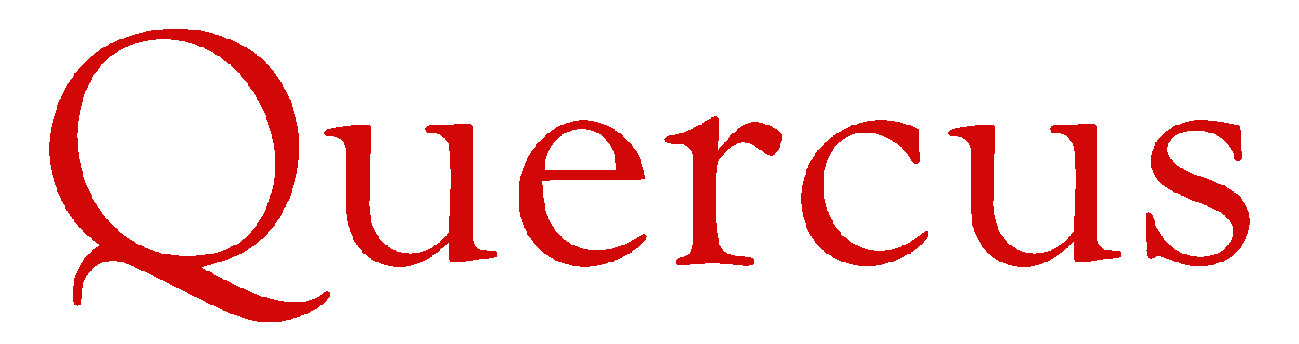

Quercus Takes Over Distribution of
Teach Yourself Line from McGraw-Hill Education

April 27, 2015
Quercus, a Hachette company, is delighted to announce that it is taking over distribution of the Teach Yourself line of self-instruction books and book-plus product from longtime North American distributor McGraw-Hill Education.
Quercus will begin to distribute the backlist titles into the trade beginning June 1, 2015, and front list titles beginning September 1, 2015.
Commenting on the addition of the line, Quercus publisher Nathaniel Marunas said:
“We are thrilled to be adding this diverse and rich line of self-instruction titles to our offering. Teach Yourself has a decades-long history of creating the highest quality language courses, and business, self-development, lifestyle and hobby titles and we are proud to be part of the next chapter in that history.”
On handing over the distribution reins after his company’s long association with Teach Yourself in North America, Christopher Brown, Publisher at the Professional Group at McGraw-Hill Education, said:
“We are proud to have represented such an institution in self-instructional publishing as Teach Yourself in North America, for fifteen years with McGraw-Hill Professional, and a further eight years before that with National Textbook Company. We have greatly appreciated not only the quality and broad range of the publishing program, but also our close partnership with the team at Teach Yourself, and we wish all continued success for the line with Quercus in the years ahead.“
About Quercus
Quercus is a Hachette company that publishes a range of high-quality commercial, literary, and translated fiction as well as illustrated nonfiction, science fiction, fantasy, horror, young adult, and juvenile titles under the imprints Quercus, MacLehose Press, Quercus Children’s Books, Jo Fletcher Books, and Heron Books.
About McGraw-Hill Education
McGraw-Hill Education is a learning science company that delivers personalized learning experiences to help students, parents, educators and professionals drive results. McGraw-Hill Education has offices across North America, India, China, Europe, the Middle East and South America, and makes its learning solutions available in more than 60 languages. Visit us at mheducation.com or find us on Facebook or Twitter.

About Teach Yourself
Since its conception in 1938, Teach Yourself has become the trusted brand for over 60 million readers, with over 500 titles in total and currently the world’s largest publisher of foreign language courses. Our publishing is characterized by our passion, expertise and heritage. Teach Yourself has successfully helped tens of millions of people worldwide to achieve their personal and professional goals.

