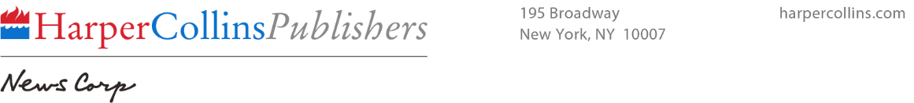
News

Contact:
Erin Crum
HarperCollins Publishers
212-207-7223
Erin.Crum@HarperCollins.com
FOR IMMEDIATE RELEASE

HarperCollins Publishers Announces Launch of Agent Portal
Provides Self-Serve Access to Sales Data, Royalty Information and More

New York, NY (July 21, 2015) – HarperCollins Publishers today announced the launch of a secure Agent Portal that will provide the company’s community of agents with royalty statements, U.S. sales data and anti-piracy information related to their HarperCollins authors.

The portal will offer access to the most recent U.S. sales data, broken down by sales channel, as well as estimated lifetime sales for each author’s titles. It will include royalty statements from June 2014 going forward, with the ultimate goal of phasing out paper royalty statements. Additionally, the portal will provide current information on anti-piracy efforts and take-down notices for each ISBN, as well as a feature that allows users to easily report piracy.

“We spent a great deal of time speaking with the agent community in order to understand what information they most wanted access to and how to deliver it in a simplified, user friendly way,” said Chantal Restivo-Alessi, Chief Digital Officer and Executive Vice President, International for HarperCollins Publishers. “Our goal is to both fulfill agents’ needs and help them better fulfill the needs of their authors. We see the HarperCollins Agent Portal as a tool to help agents, and through them, our authors, gain access to the information they want in a timely fashion.”

The HarperCollins portal is currently only available to the company’s U.S. agent population. Based on the initial feedback it may expand to other locations.

Agents who have not yet received access to the Agent Portal may inquire by emailing
APSupport@HARPERCOLLINS.com.

