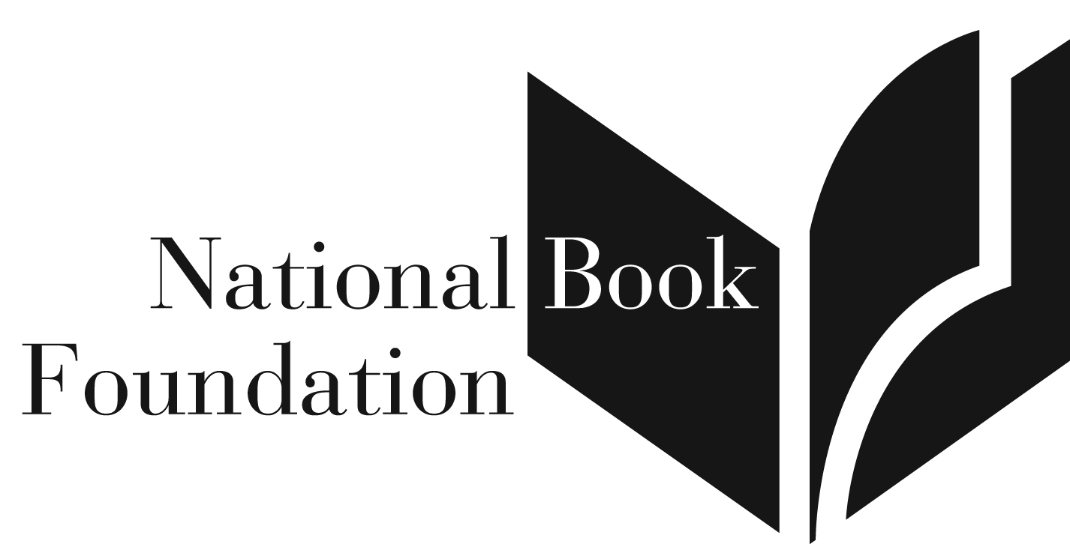

RELEASE: SEPTEMBER 14, 2015 CONTACT: Sherrie Young
9:30 a.m. EDT National Book Foundation
(212) 685-0261/cell: (917) 612-8078
syoung@nationalbook.org

2015 National Book Awards Longlist
For Young People’s Literature
The ten contenders for the National Book Award for
Young People’s Literature

New York, NY (September 14, 2015) – The National Book Foundation announces the Longlist for the 2015 National Book Award for Young People’s Literature. Finalists will be revealed on October 14.

Among this year’s ten Longlisted books is a past National Book Award Winner, a two-time National Book Award Finalist, a three-time Newbery Honor Book recipient, a Michael L. Printz Honor Book recipient, and an Eisner Award winner. Three novels are by debut authors.

The range of writing styles and genres of the ten titles on the Longlist is wide and addresses contemporary teen issues such as coming-out, coming-of-age, mental illness, and accepting loss. There are three nonfiction books: One uses music as an entry into Russian history, another focuses on a central figure in the politics of the war in Vietnam, and a third is a memoir of the author’s relationship with animals. There are six novels, one based on the early years of civil-rights leader Malcolm X, written by his daughter; and a graphic novel with the female sidekick of a supervillain, which was first serialized on the web. The Longlist also presents a novel that blends folklore and mythology.
2015 Longlist for the National Book Award for Young People’s Literature:

Becky Albertalli, Simon vs. the Homo Sapiens Agenda
Balzer + Bray/HarperCollins Children's Books

M. T. Anderson, Symphony for the City of the Dead: Dmitri Shostakovich and the Siege of Leningrad, Candlewick Press
Ali Benjamin, The Thing About Jellyfish
Little, Brown Books for Young Readers/Hachette Book Group

Rae Carson, Walk on Earth a Stranger
Greenwillow Books/HarperCollins Children's Books

Gary Paulsen, This Side of Wild: Mutts, Mares, and Laughing Dinosaurs
Simon & Schuster Children's Publishing
Laura Ruby, Bone Gap
Balzer + Bray/HarperCollins Children's Books

Ilyasah Shabazz with Kekla Magoon, X: A Novel
Candlewick Press

Steve Sheinkin, Most Dangerous: Daniel Ellsberg and the Secret History of the Vietnam War
Roaring Brook Press/Macmillan Children's Publishing Group

Neal Shusterman, Challenger Deep
HarperTeen/HarperCollins Children's Books

Noelle Stevenson, Nimona
HarperTeen/HarperCollins Children's Books

Biographies:
Becky Albertalli is a clinical psychologist who has worked with teenagers. She also served for seven years as co-leader of a support group for gender nonconforming children in Washington, DC. Simon vs. the Homo Sapiens Agenda is her debut novel. She lives in Atlanta. www.beckyalbertalli.com
M.T. Anderson is the author of several books for children and young adults, including Feed, which was a Finalist for the National Book Award in 2002 and winner of the Los Angeles Times Book Prize; and The Astonishing Life of Octavian Nothing, Traitor to the Nation, Volume I: The Pox Party, which won the National Book Award in 2006 and was named a Michael L. Printz Honor Book. www.mt-anderson.com

Ali Benjamin is the co-author of Tim Howard's best-selling memoir The Keeper and, with Paige Rawl, Positive, which was a Junior Library Guild selection and the first nonfiction selection for The Today Show book club; and The Cleaner Plate Club. The Thing about Jellyfish is her debut novel. www.alibenjamin.com

Rae Carson is the author of the Fire and Thorns trilogy, the first book of which, The Girl of Fire and Thorns, was a finalist for the William C. Morris Young Adult Debut Award and the Andre Norton Award and winner of the Ohioana Book Award for Young Adult Literature; was selected as 2012 Top Ten Best Fiction for Young Adults by Young Adult Library Services Association, and was a New York Times and USA Today bestseller. She lives in Arizona. www.raecarson.com

Gary Paulsen has written more than a hundred books for adults and young readers. He is the author of three Newbery Honor titles: Dogsong, Hatchet, and The Winter Room. In 1997 Paulsen received the Margaret A. Edwards Award, which honors an author’s lifetime contribution to young adult literature. He divides his time between New Mexico and a boat on the Pacific. www.garypaulsen.com

Laura Ruby writes fiction for children, young adults, and adults. Her children’s book Lily’s Ghosts was nominated for the Edgar Award and her young adult novel Good Girls was an ALA Quick Pick for teens. She is on the faculty of Hamline University's Masters in Writing for Children Program. She makes her home in the Chicago area. www.lauraruby.com

Ilyasah Shabazz is the daughter of Malcolm X and the author of Malcolm Little and Growing Up X: A Memoir. She co-edited, with Herb Boyd, The Diary of Malcolm X and worked with illustrator AG Ford on The Boy Who Grew Up to Become Malcolm X. She lives in Westchester County, New York. www.ilyasahshabazz.com.
Kekla Magoon is the author of five young adult novels including How It Went Down and The Rock and the River, for which she received the ALA’s Coretta Scott King-John Steptoe New Talent Author Award and an NAACP Image Award nomination. She also writes non-fiction on historical topics, including Today the World is Watching You: The Little Rock Nine and the Fight for School Integration 1957 and the forthcoming PANTHERS! The History and Legacy of the Black Panther Party in America. She lives in New York City. www.keklamagoon.com.

Steve Sheinkin is the author of several books on American history for young adults including BOMB: The Race to Build—and Steal—the World’s Most Dangerous Weapon, which was a finalist for the National Book Award, awarded a Newbery Honor, and won the Sibert Medal, the YALSA Award for Excellence in Nonfiction for Young Adults; and The Port Chicago 50: Disaster, Mutiny, and the Fight for Civil Rights, which was a finalist for the National Book Award and winner of the Boston Globe/Horn Book Award for nonfiction. He lives in Saratoga Springs, New York. www.stevesheinkin.com

Neal Shusterman is the author of many novels for young adults, including Unwind, which was an ALA Best Book for Young Adults and a Quick Pick for Reluctant Young Readers, Everlost, and Downsiders, which was nominated for twelve state reading awards. He also writes screenplays for motion pictures and television shows such as Animorphs and Goosebumps. He lives in southern California. www.storyman.com

Noelle Stevenson’s Nimona was a New York Times bestseller, and is her first solo work. She was nominated for a Harvey Award and was awarded the Slate Cartoonist Studio Prize for Best Web Comic in 2012 for Nimona. A graduate of the Maryland Institute College of Art, She is a writer on Disney’s Wander Over Yonder, the co-writer for Lumberjanes, which won an Eisner Award for "Best New Series" and "Best Publication for Teens (Age 13-17);" and has written for Marvel and DC Comics. She lives in Los Angeles. www.gingerhaze.com

2015 National Book Award Judges for Young People’s Literature:

John Joseph Adams is the series editor of Best American Science Fiction & Fantasy. He is also the editor of the bestselling anthologies The Mad Scientist’s Guide to World Domination and The Living Dead, which was nominated for a World Fantasy Award and named one of the "Best Books of the Year" by Publishers Weekly. In 2011, he was a finalist for the 2011 Hugo Award for Best Professional Editor, Short Form. He is also editor of Lightspeed magazine, which won the Hugo Award in 2014 for Best Semiprozine.

Teri Lesesne is a professor in the Department of Library Science at Sam Houston State University in Huntsville, Texas, where she teaches courses in literature for children and young adults. A former middle school English teacher, Teri is the Executive Director of ALAN, the Assembly on Literature for Adolescents of the National Council of Teachers of English. She is the author of three books for reading professionals.

Laura McNeal holds an MA in fiction writing from Syracuse University and is the author of Dark Water, a 2010 Finalist for the National Book Award in Young People’s Literature, and You Can’t Leave Me Now: Three Stories of True Crime. She and her husband Tom McNeal are the authors of Crooked, Zipped, Crushed, and The Decoding of Lana Morris. Her forthcoming novel, The Incident on the Bridge, will be published by Knopf in the spring of 2016. www.mcnealbooks.com

G. Neri is the Coretta Scott King honor-winning author of Yummy: the Last Days of a Southside Shorty and is a recipient of the Lee Bennett Hopkins Promising Poet Award for his free-verse novella, Chess Rumble. His novels include Knockout Games, Surf Mules, and the Horace Mann Upstander Award-winning Ghetto Cowboy. His forthcoming novel, Tru & Nelle, about the childhood friendship between Harper Lee and Truman Capote, will be published by Houghton Mifflin Harcourt in the March of 2016. www.gneri.com

Eliot Schrefer is the New York Times bestselling author of Endangered and Threatened, both Finalists for the National Book Award in Young People’s Literature. His novels have also been named “Editor’s Choice” in the New York Times, best of the year by NPR, and have won the Green Earth Book Award and the Sigurd Olson Nature Writing Award. He lives in New York City, where he is also on the faculty of Fairleigh Dickinson University’s MFA in Creative Writing. www.eliotschrefer.com

Publishers submitted a total of 294 books for the 2015 National Book Award in Young People’s Literature. Five distinguished judges were given the charge of selecting what they deem to be the best books of the year. Their decisions are made independently of the National Book Foundation staff and Board of Directors; deliberations are strictly confidential. To be eligible for a 2015 National Book Award, a book must have been written by a US citizen and published in the United States between December 1, 2014 and November 30, 2015.

The remaining Longlists for the Poetry, Nonfiction, and Fiction categories will be revealed exclusively at newyorker.com at 9 a.m. EDT as follows: Poetry on Tuesday, September 15; Nonfiction on September 16; and finally, the Longlist for Fiction on September 17.

The National Book Award Finalists will be announced on October 14 and the Winners at the invitation-only National Book Awards Ceremony and Benefit Dinner on November 18 in New York City.

# # # #
The National Book Foundation's mission is to celebrate the best of American literature, to expand its audience, and to enhance the cultural value of good writing in America. In addition to the National Book Awards, for which it is best known, the Foundation's programs include 5 Under 35, a celebration of emerging fiction writers selected by former National Book Award Finalists and Winners; the National Book Awards Teen Press Conference, an opportunity for New York City students to interview the current National Book Award Finalists in Young People's Literature; NBA on Campus, a partnership that brings National Book Award authors to colleges across the country; the Innovations in Reading Prize, awarded to individuals and institutions that have developed innovative means of creating and sustaining a lifelong love of reading; and BookUp, a writer-led, after-school reading program for middle-school students.

The National Book Award is one of the nation's most prestigious literary prizes and has a stellar record of identifying and rewarding quality writing. In 1950, William Carlos Williams was the first Winner in Poetry, the following year William Faulkner was honored in Fiction, and so on through the years. Many previous Winners of a National Book Award are now firmly established in the canon of American literature, such as Sherman Alexie, Louise Erdrich, Jonathan Franzen, Denis Johnson, James McBride, Joyce Carol Oates, and Adrienne Rich.

